4: Bank Account System using Data Hiding:
Problem Understanding
Aim
To design a Bank Account System using Encapsulation (Data Hiding) in Java.
The program should:
- Store account details securely using private variables.
- Allow users to deposit money.
- Allow users to withdraw money.
- Display the available balance.
- Prevent invalid transactions.
Requirements
Create a class BankAccount with the following private data members:
- accountNumber
- holderName
- balance
Implement methods:
- deposit()
- withdraw()
- displayBalance()
The program should be menu-driven.
Constraints
- Deposit amount must be greater than 0.
- Withdrawal amount must be greater than 0.
- Withdrawal amount should not exceed available balance.
- Balance should not be directly modified outside the class.
Expected Learning Outcome
- Understand Data Hiding.
- Implement Encapsulation.
- Use constructors and methods.
2. Algorithm
- Start.
- Read account number.
- Read account holder name.
- Read initial balance.
- Create a BankAccount object.
- Display the following menu:
  - Deposit
  - Withdraw
  - Balance Enquiry
  - Exit
- Read the user's choice.
- If Deposit:
  - Read amount.
  - Validate amount.
  - Update balance.
- If Withdraw:
  - Read amount.
  - Check sufficient balance.
  - Deduct amount.
- If Balance Enquiry:
  - Display current balance.
- Repeat until the user chooses Exit.
- Stop.

Program Implementation:
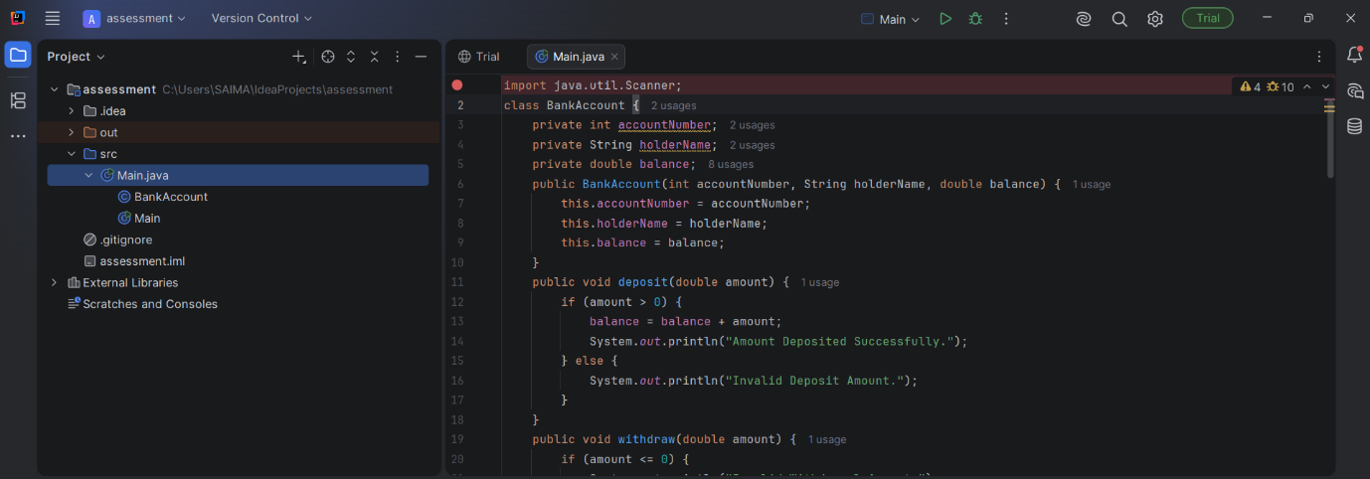
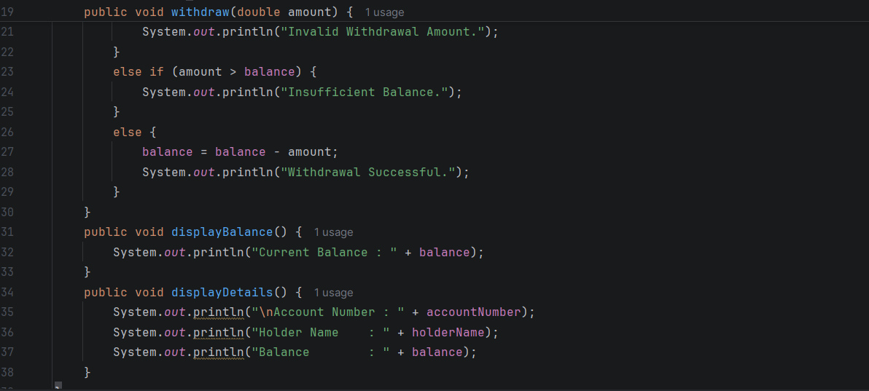
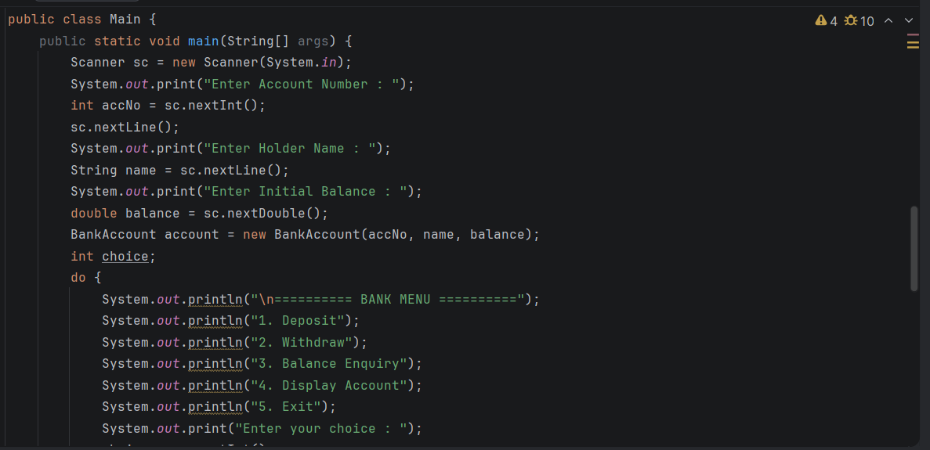
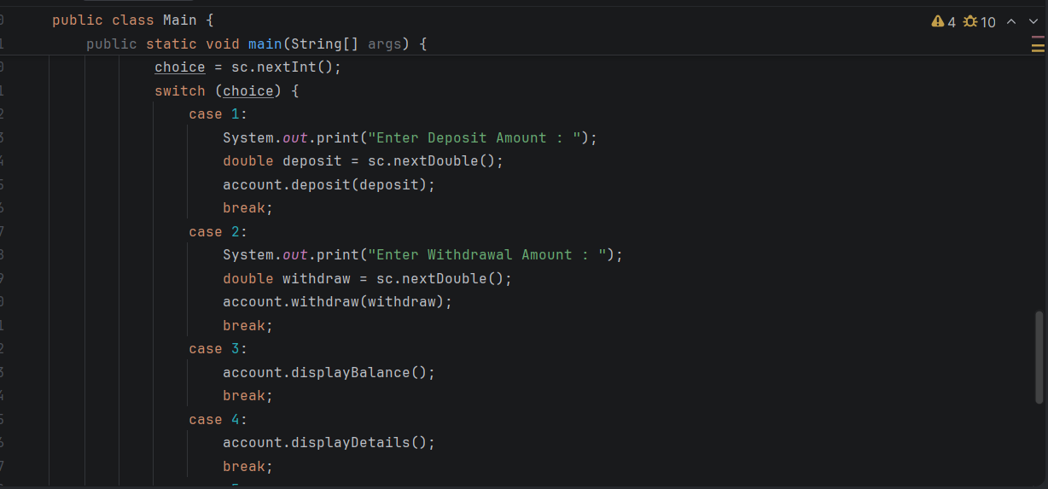
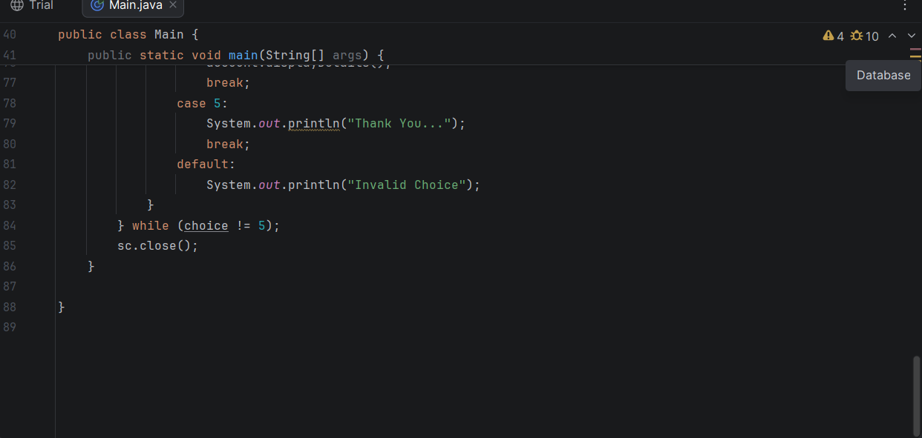
OUTPUT:
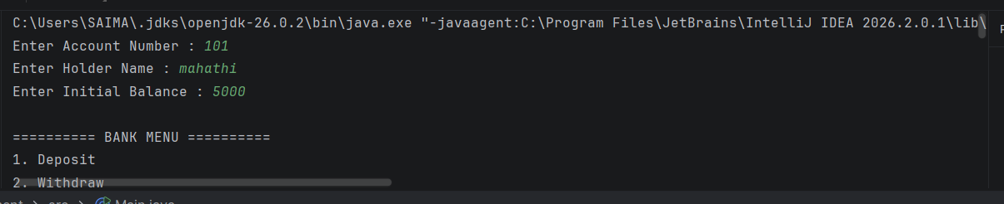
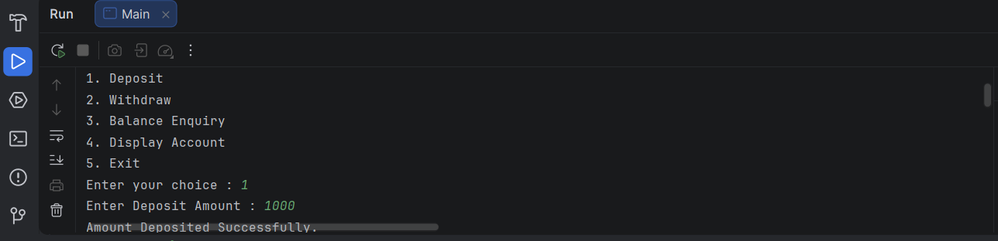
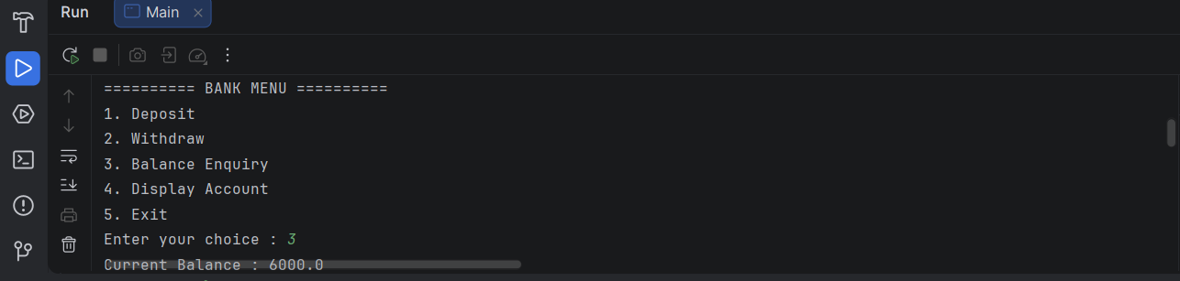
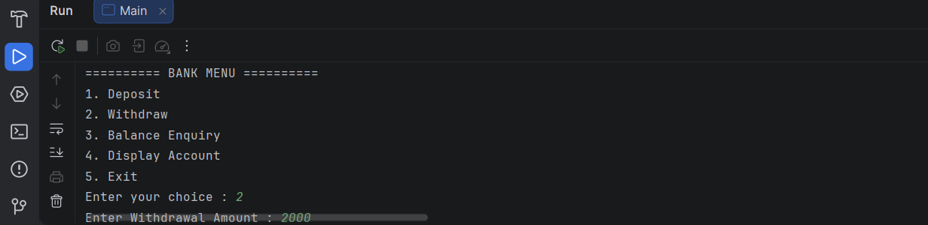
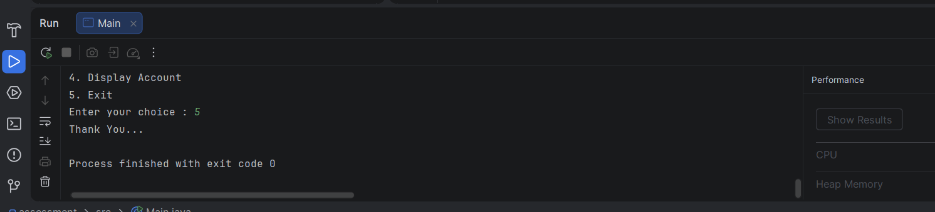
4. Competitive Performance
Time Complexity
Operation | Time Complexity
Deposit | O(1)
Withdraw | O(1)
Display Balance | O(1)
Display Details | O(1)
Space Complexity O(1)
Only one BankAccount object is created, so the extra memory used is constant.
5. Test Case Handling
Test Case | Input | Expected Output
TC1 | Deposit = 1000 | Amount Deposited Successfully
TC2 | Deposit = -500 | Invalid Deposit Amount
TC3 | Withdraw = 500 | Withdrawal Successful
TC4 | Withdraw > Balance | Insufficient Balance
TC5 | Withdraw = -100 | Invalid Withdrawal Amount
TC6 | Balance Enquiry | Displays Current Balance
TC7 | Display Details | Shows Account Number, Holder Name, and Balance

5: University Admission System using Method Overloading
1. Problem Understanding
Aim
To develop a University Admission System using Method Overloading in Java.
The program calculates the admission fee for:
- Undergraduate students
- Postgraduate students
- Scholarship students
using overloaded calculateFee() methods.
Requirements
Create a class Admission with overloaded methods:
- calculateFee(double ugFee)
- calculateFee(double pgFee, int years)
- calculateFee(double fee, double scholarshipPercent)
The program should allow the user to choose the admission type from a menu.
Constraints
- Fee must be greater than 0.
- Scholarship percentage must be between 0 and 100.
- Number of years must be positive.
Expected Learning Outcome
- Understand Method Overloading.
- Learn Compile-Time Polymorphism.
- Use constructors, methods, and menu-driven programming.
2. Algorithm
- Start.
- Create an object of the Admission class.
- Display the menu:
  - Undergraduate
  - Postgraduate
  - Scholarship Student
  - Exit
- Read the user's choice.
- Call the appropriate overloaded calculateFee() method.
- Display the calculated fee.
- Repeat until Exit.
- Stop.
Implementation:
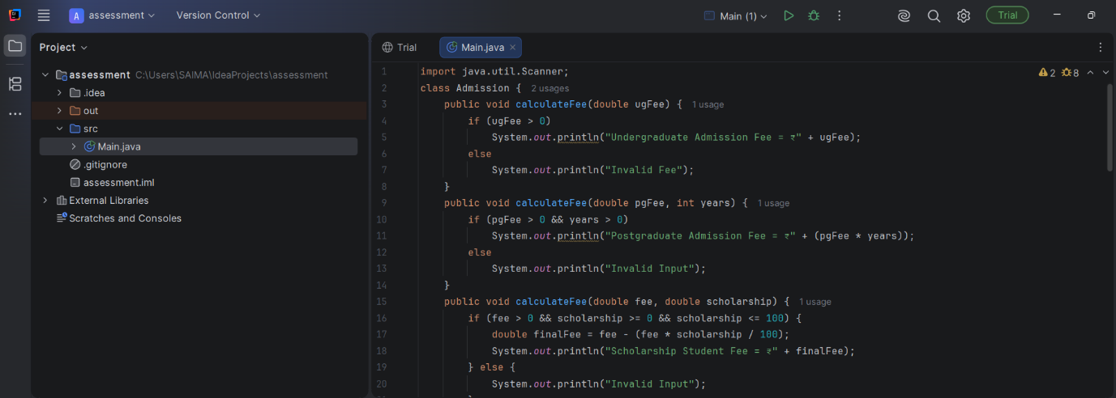
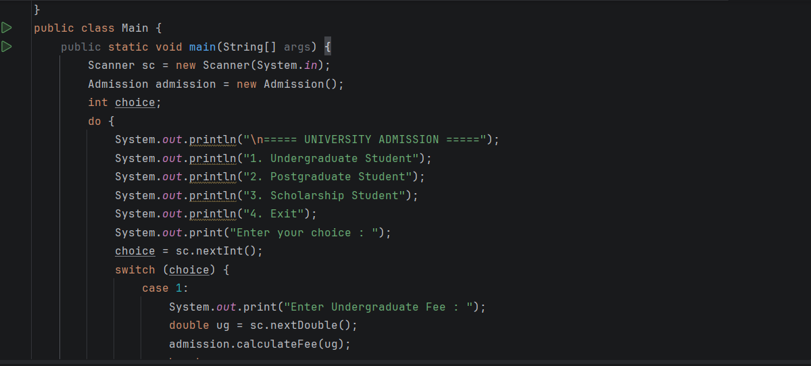
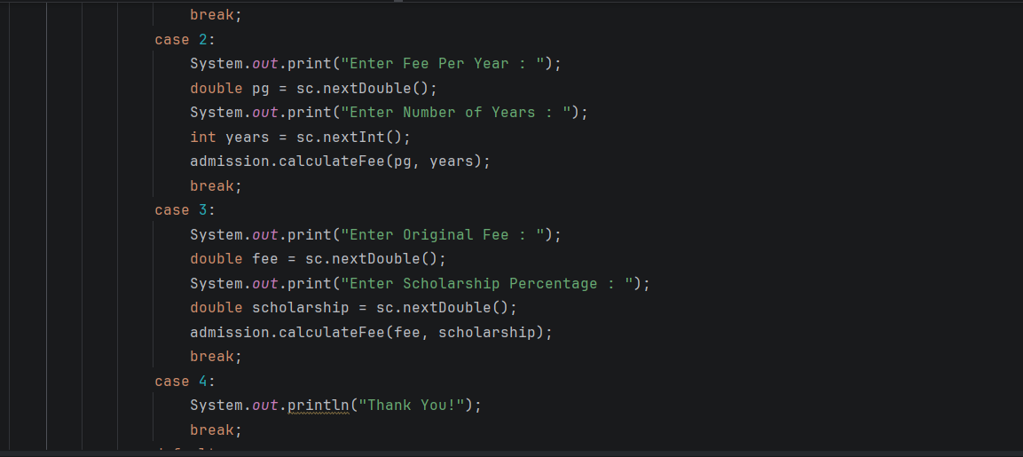
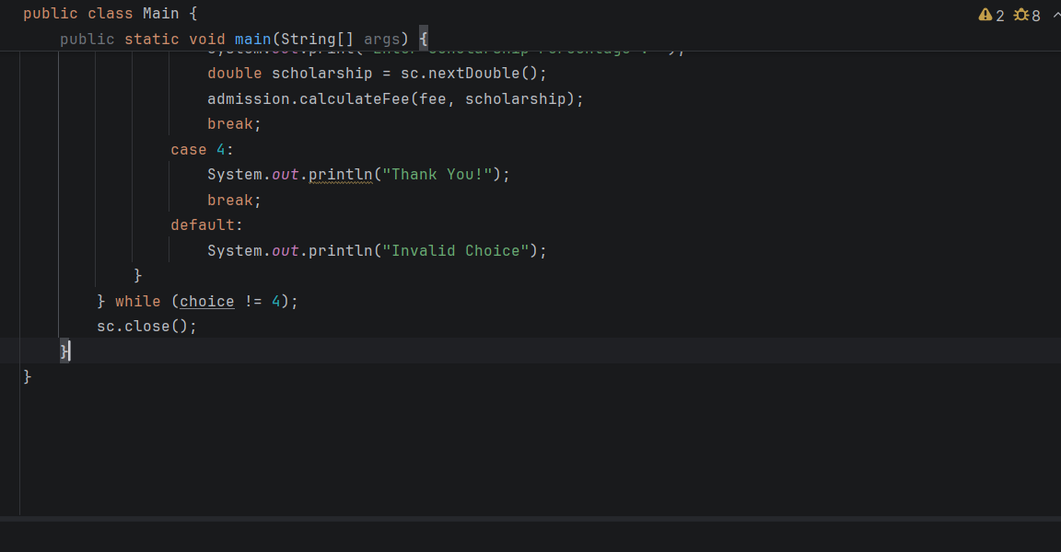

OUTPUT:
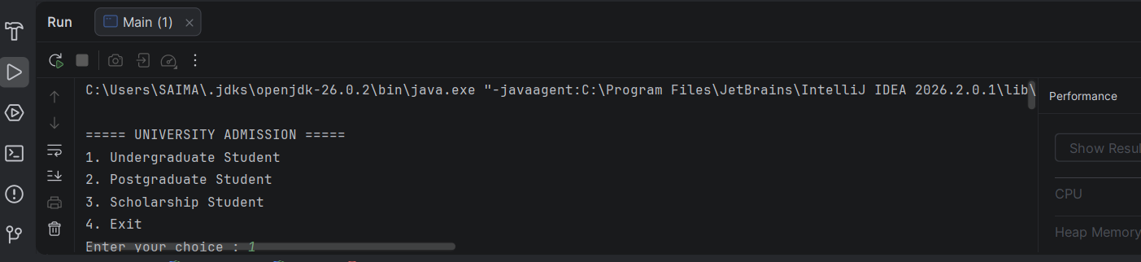
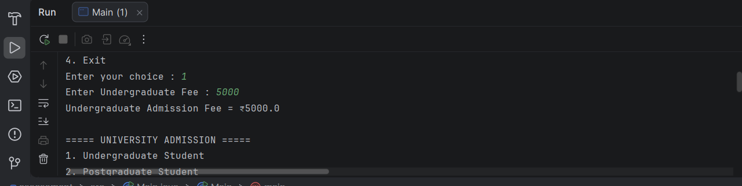
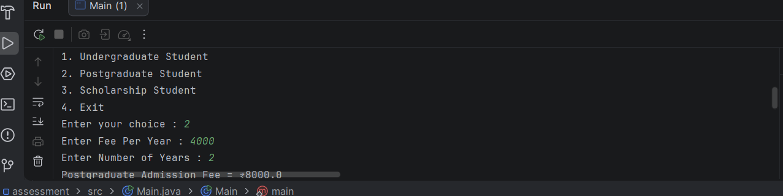
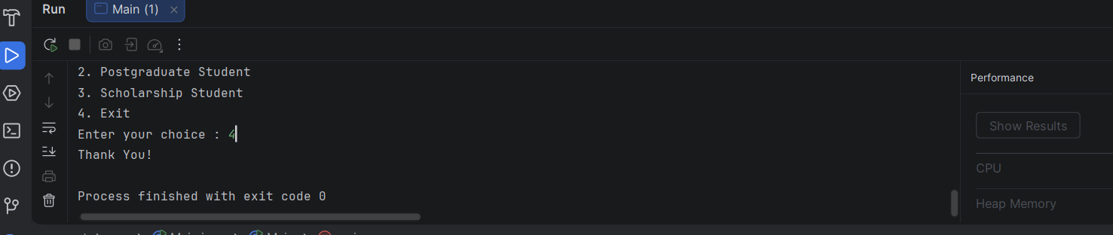
4. Competitive Performance (20%)
Time Complexity
Operation | Complexity
Undergraduate Fee | O(1)
Postgraduate Fee | O(1)
Scholarship Fee | O(1)
Space Complexity O(1)
Only one object of the Admission class is created.
5. Test Case Handling (15%)
Test Case | Input | Expected Output
TC1 | UG Fee = 50000 | Undergraduate Admission Fee = ₹50000
TC2 | PG Fee = 40000, Years = 2 | ₹80000
TC3 | Fee = 60000, Scholarship = 50 | ₹30000
TC4 | Scholarship = 110 | Invalid Input
TC5 | Fee = -5000 | Invalid Fee

9: Student Result Analyzer using Arrays of Objects
1. Problem Understanding
Aim
To design a Student Result Analyzer using Arrays of Objects in Java.
The program stores details of multiple students and calculates:
- Total Marks
- Average Marks
- Grade
- Class Topper
Requirements
Create a class Student with:
- Roll Number
- Name
- Marks in 3 Subjects
Implement methods to:
- Calculate Total
- Calculate Average
- Calculate Grade
- Display Student Details
Find the student with the highest total marks (Topper).
Constraints
- Marks should be between 0 and 100.
- Number of students should be greater than 0.
- Average should be calculated correctly.
- Grade should be assigned based on average.
Grade Criteria
Average | Grade
90 - 100 | A
75 - 89 | B
60 - 74 | C
40 - 59 | D
Below 40 | F

2. Algorithm
Algorithm
- Start.
- Read the number of students.
- Create an array of Student objects.
- Read student details.
- Calculate total and average.
- Assign grade.
- Display all student details.
- Find the student with the highest total.
- Display the topper.
- Stop.

Implementation:
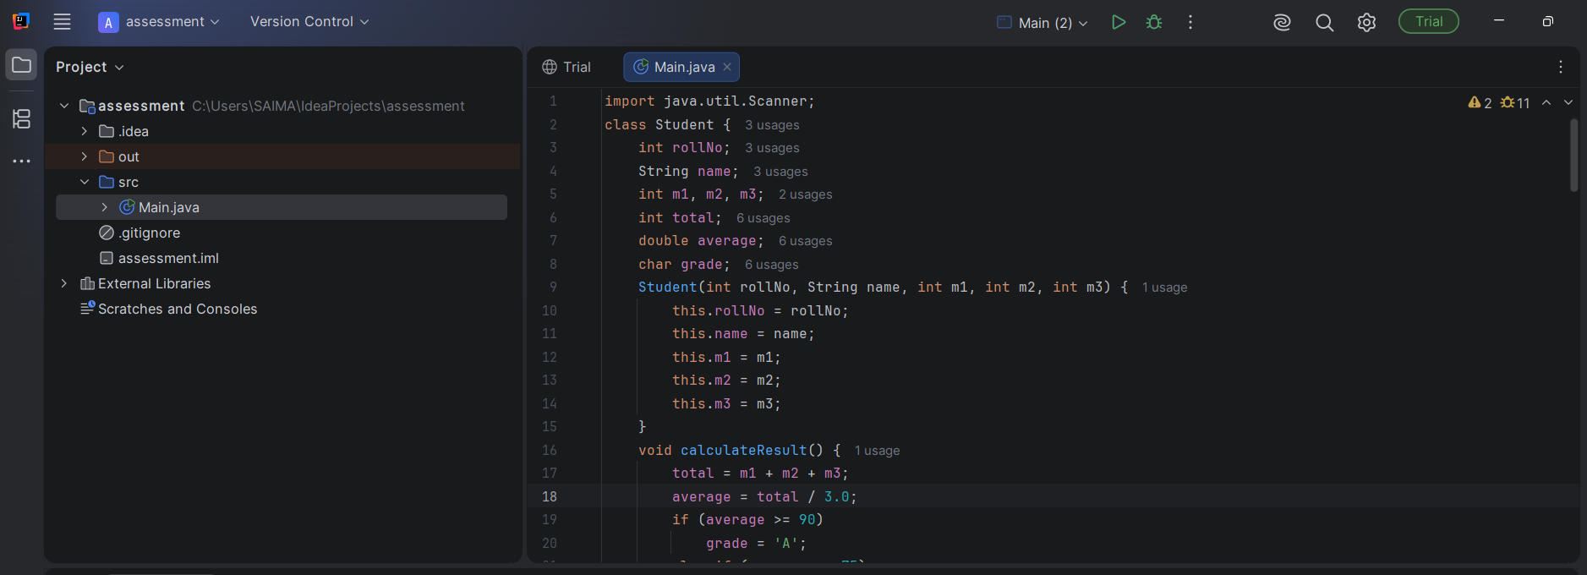
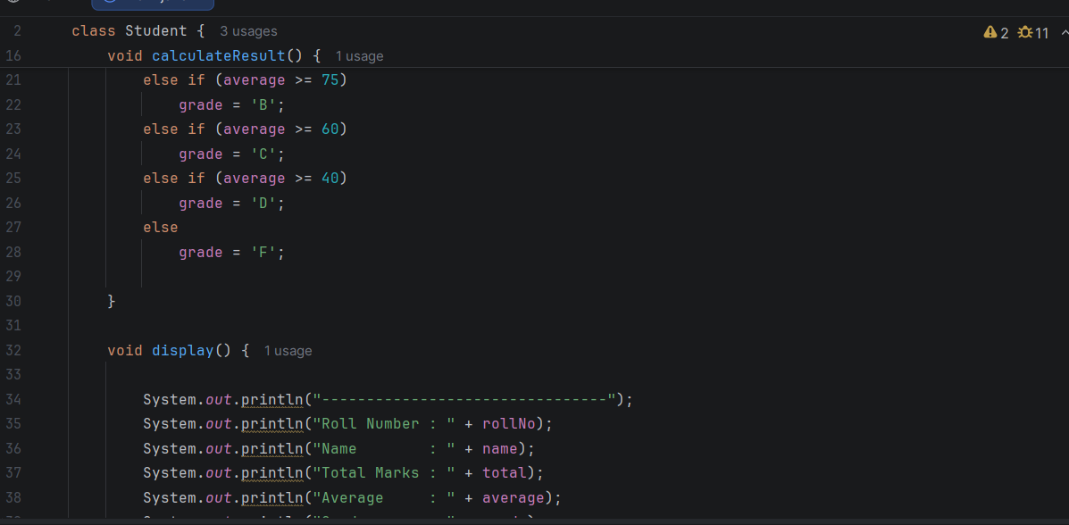
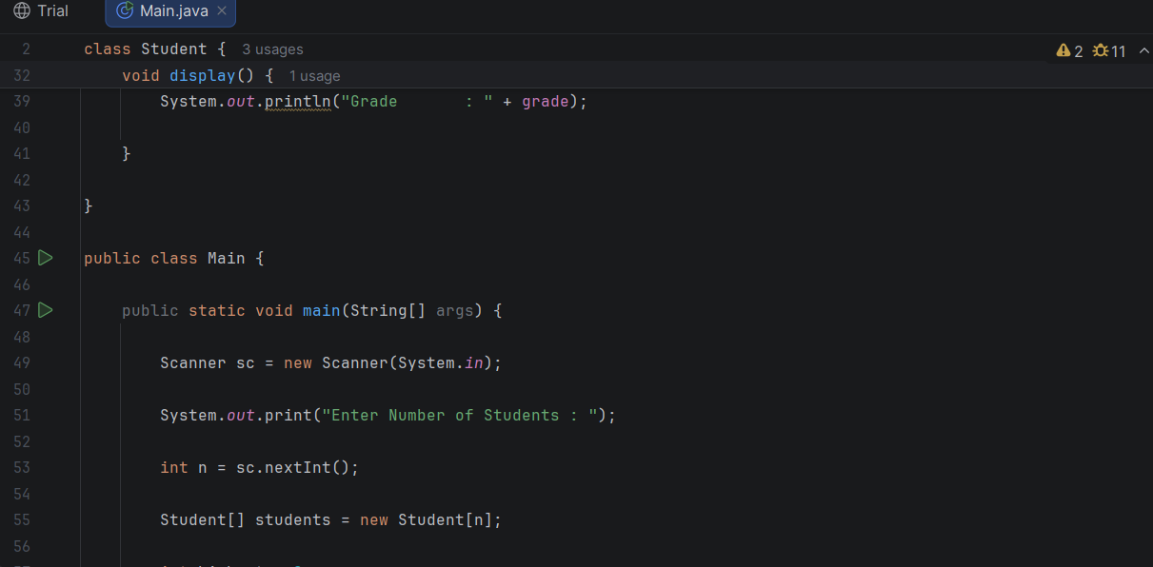
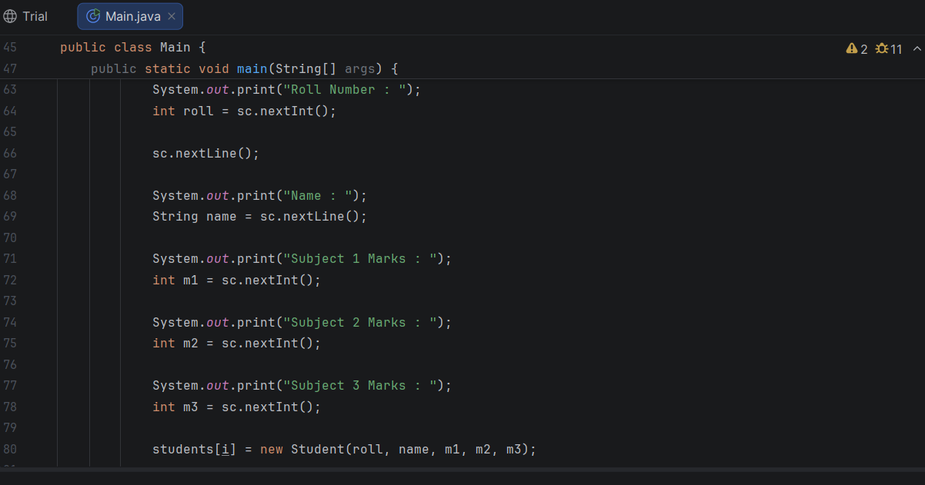
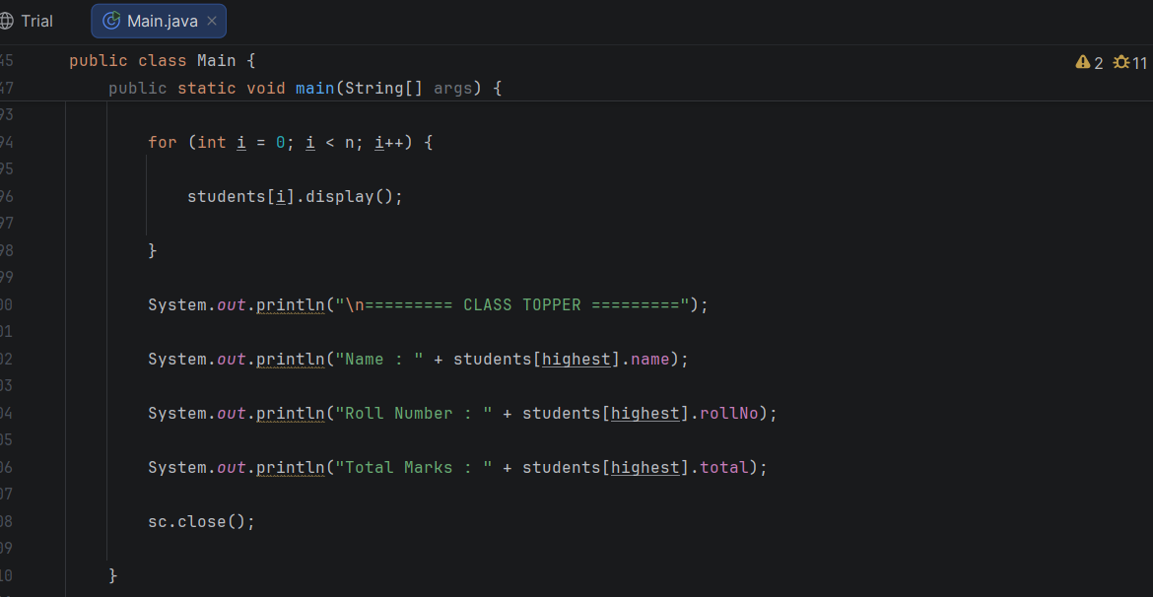
OUTPUT:
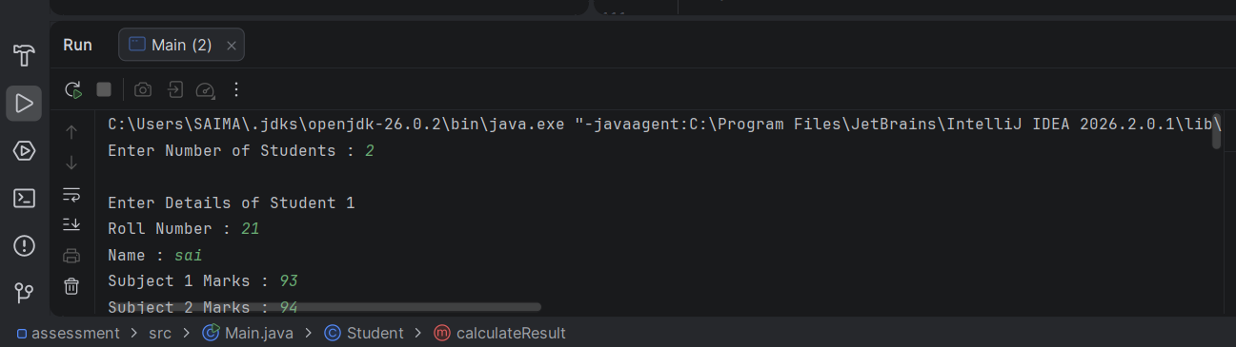
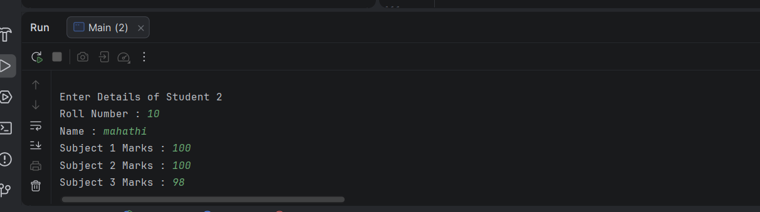
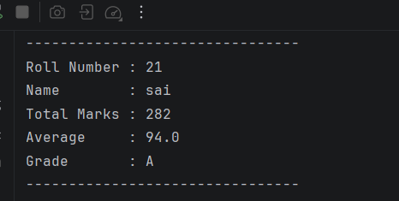
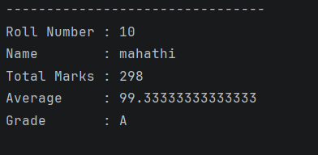
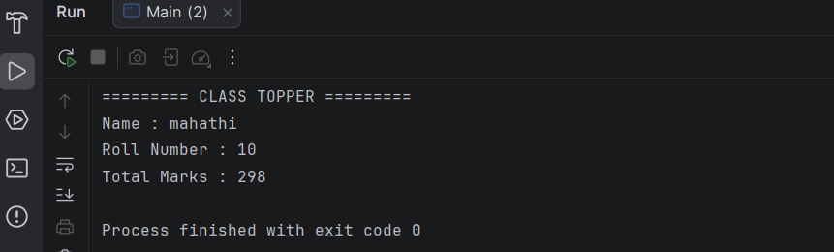
1: Library Book Management using Classes & Encapsulation:
1. Problem Understanding
Aim
Develop a Library Book Management System using Encapsulation.
The program should:
- Add a book
- Search a book
- Issue a book
- Return a book
- Display all books
Each book contains:
- Book ID
- Title
- Author
- Price
- Issue Status
Constraints
- Book ID should be unique.
- Price should be greater than zero.
- Issued books cannot be issued again.
- Only issued books can be returned.
2. Algorithm
- Start.
- Read the number of books.
- Store book details in an array of objects.
- Display menu:
  - Display Books
  - Search Book
  - Issue Book
  - Return Book
  - Exit
- Perform selected operation.
- Repeat until Exit.
- Stop.

Implementation:
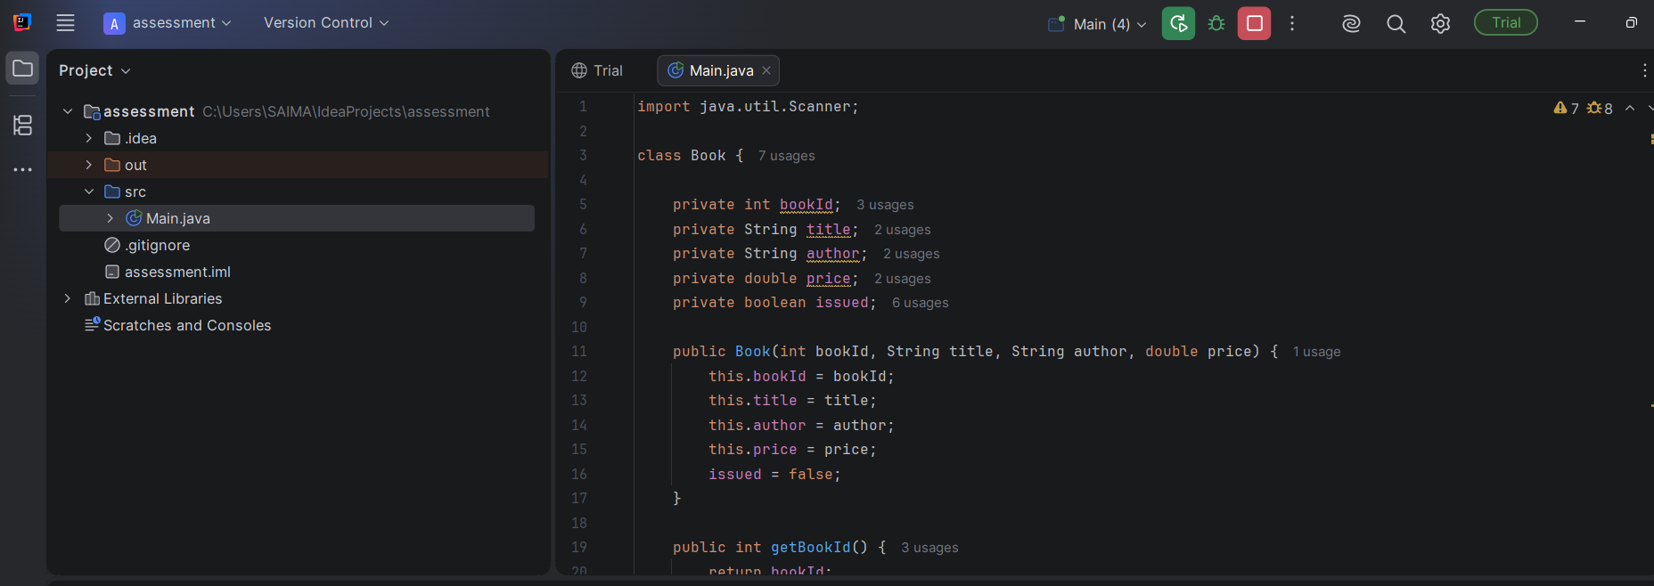
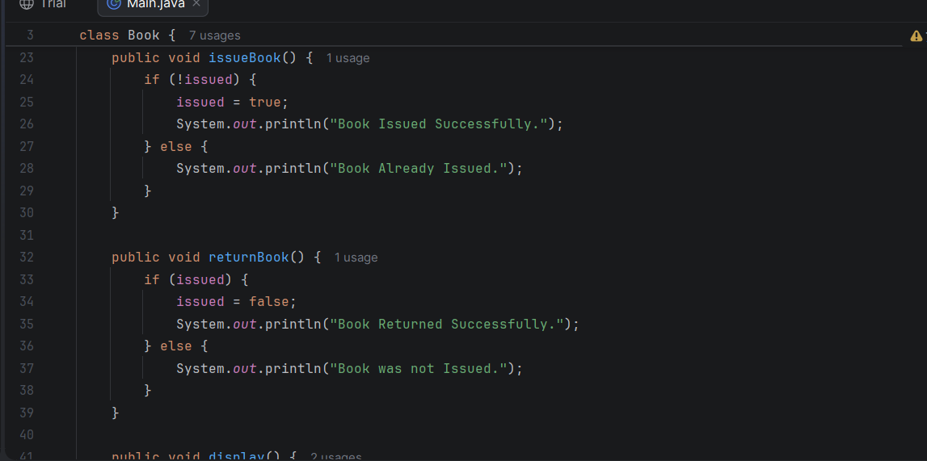
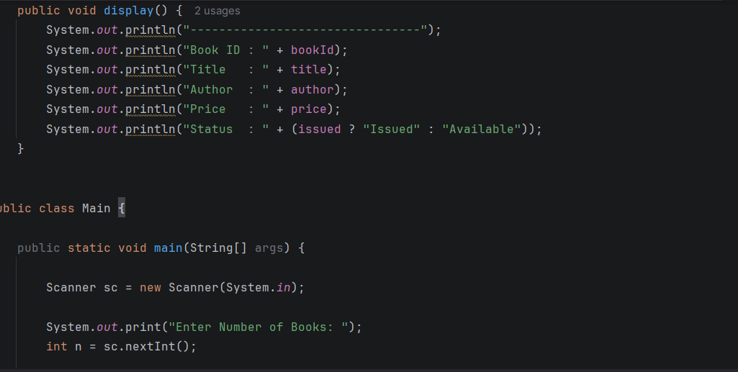
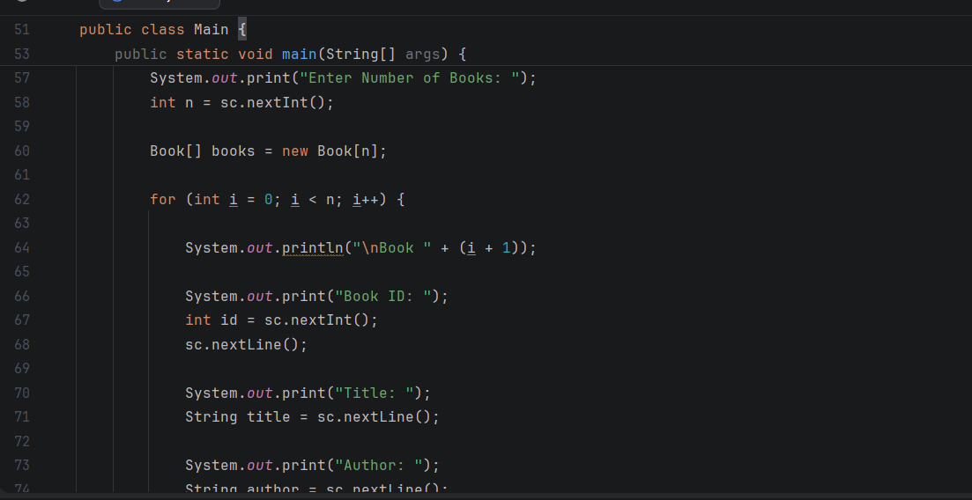
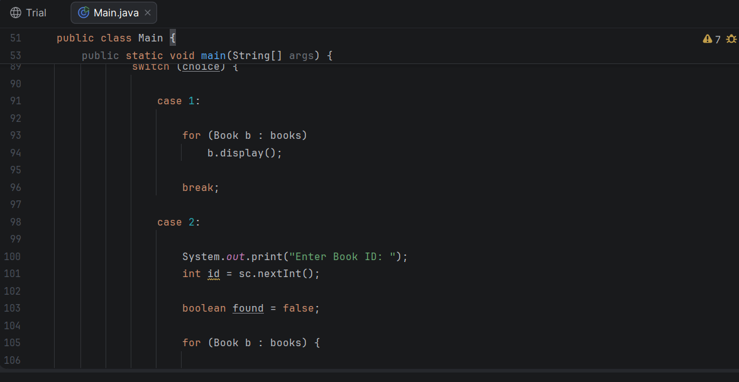
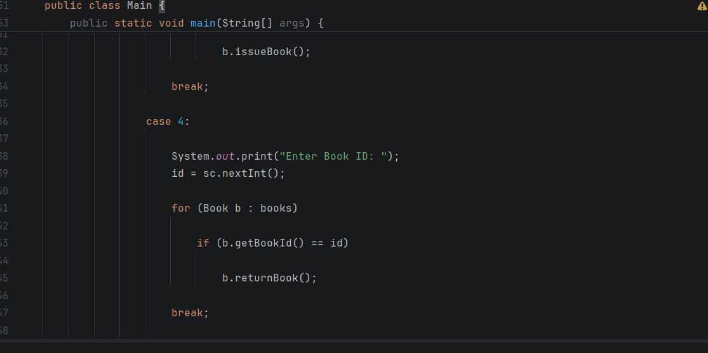
Output:
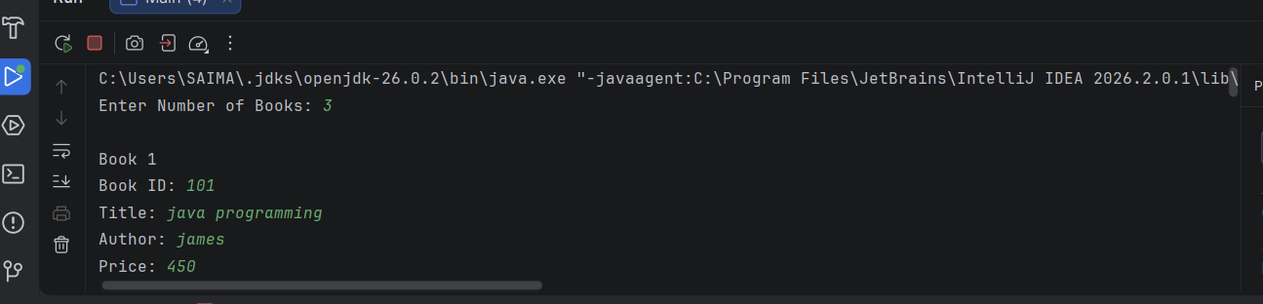
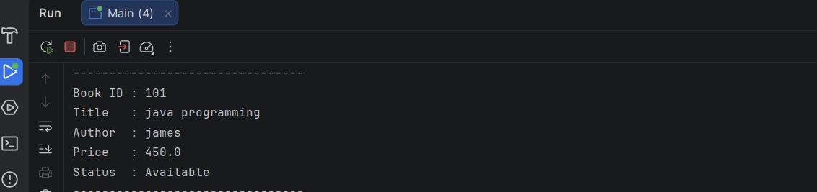
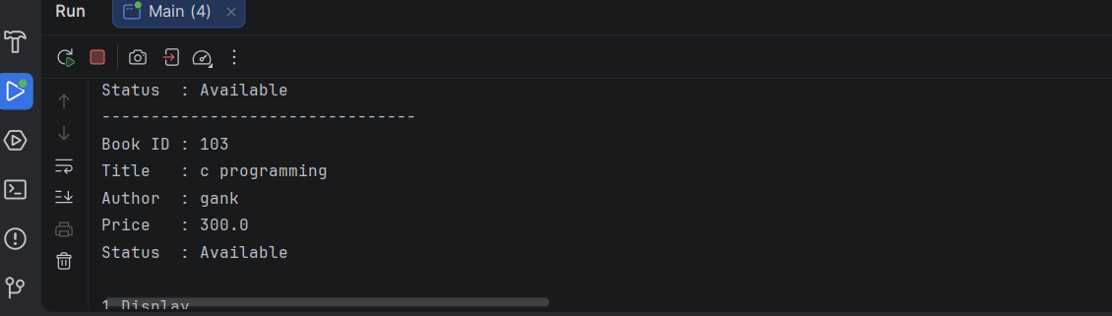

2: Employee Payroll System using Inheritance
1. Problem Understanding
Aim
Develop an Employee Payroll System using Inheritance.
Create:
- Employee (Base Class)
- PermanentEmployee
- ContractEmployee
Each class should override the calculateSalary() method.
2. Algorithm
- Start.
- Create Employee reference.
- Create PermanentEmployee object.
- Create ContractEmployee object.
- Call calculateSalary() using runtime polymorphism.
- Display employee details.
- Stop.
Implementation:
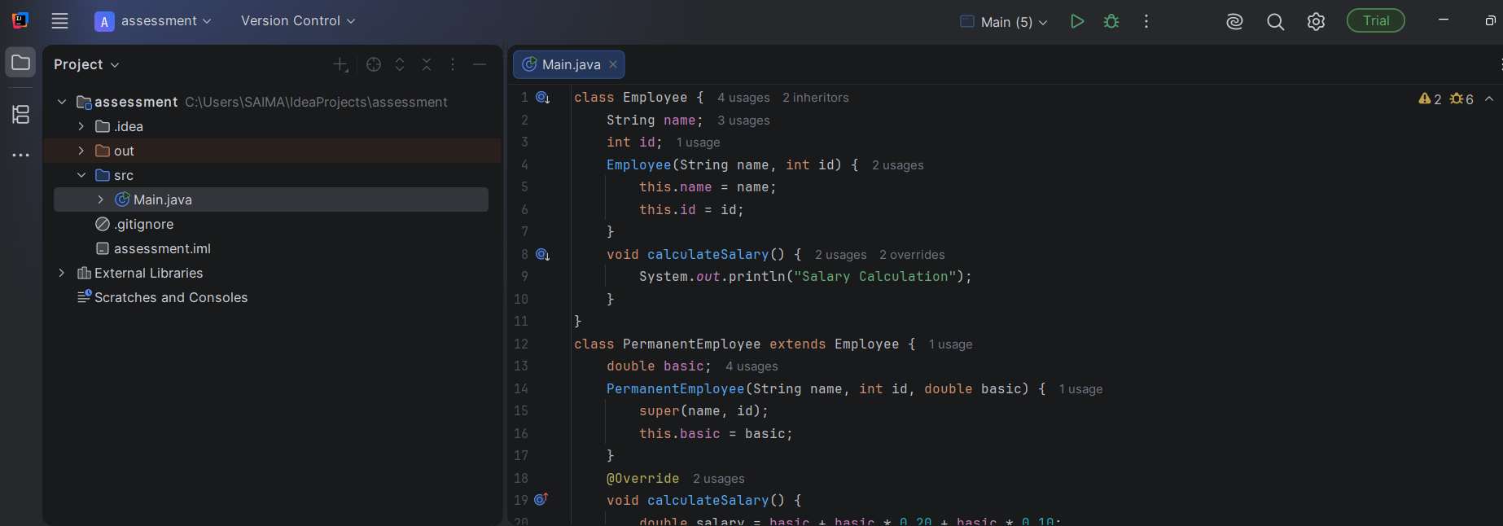
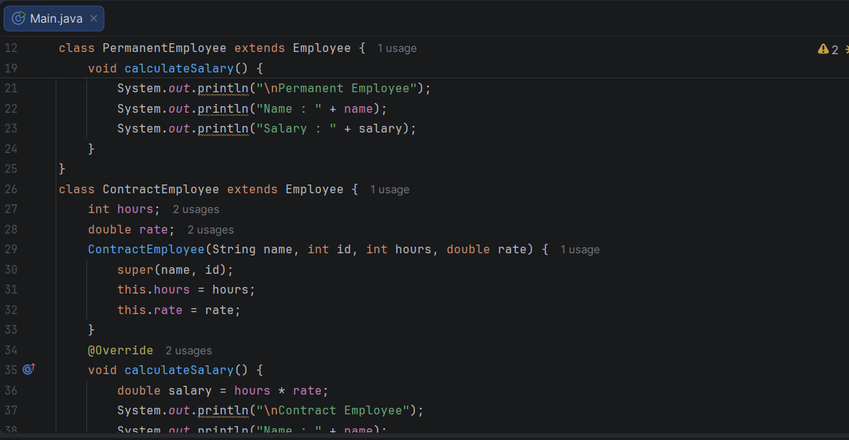
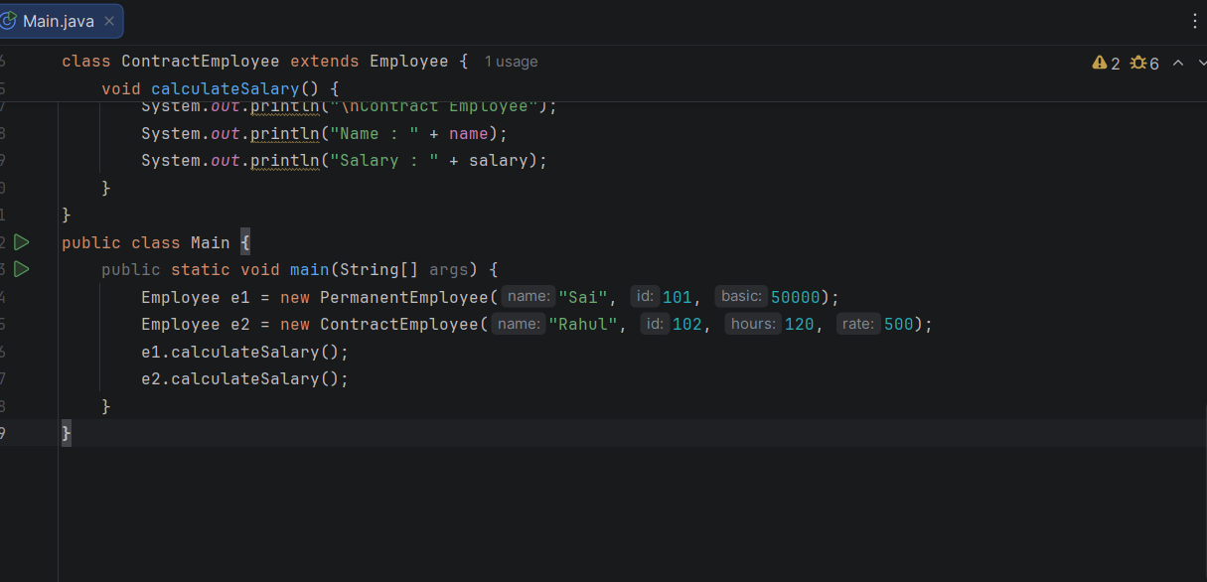
Output:
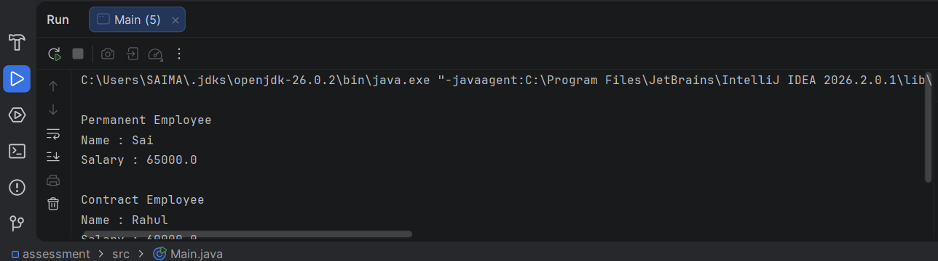
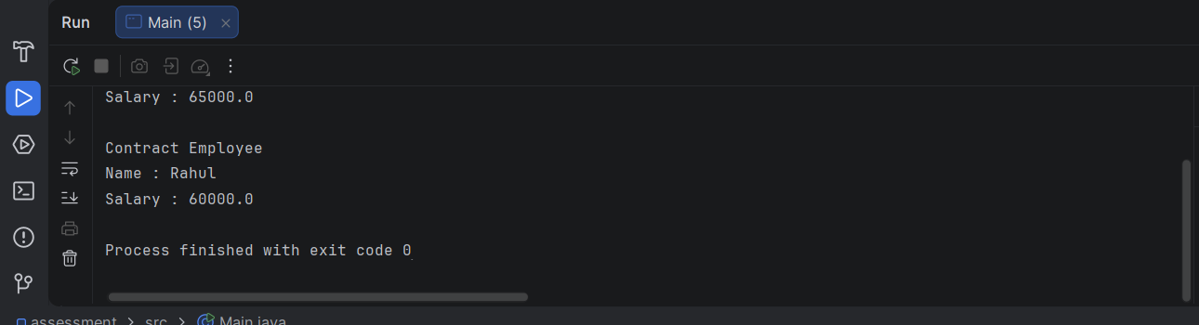
4. Competitive Performance
Operation | Complexity
Calculate Permanent Salary | O(1)
Calculate Contract Salary | O(1)
Display Details | O(1)
Space Complexity: O(1)

5. Test Cases
Employee Type | Input | Expected Salary
Permanent | Basic = 50000 | 65000
Contract | 120 × 500 | 60000
Contract | Hours = 0 | 0
Permanent | Basic = 0 | 0

